# Improvement in Detection of plant disease using image processing with multithreading techniques (A Review)

Muhammad Aslam

CS Department, UET, Lahore

[maslam@uet.edu.pk](mailto:maslam@uet.edu.pk)

Ayesha Atif

CS Department, UET, Lahore

[2020mscs578@student.uet.edu.pk](mailto:2020mscs578@student.uet.edu.pk)

Hamza Farooq

CS Department, UET, Lahore

[2020mscs513@student.uet.edu.pk](mailto:2020mscs513@student.uet.edu.pk)

Komal Shehzadi

CS Department, UET, Lahore

[2020mscs590@student.uet.edu.pk](mailto:2020mscs590@student.uet.edu.pk)

## Abstract

Pakistan is an agricultural Country. The crops play an important part in the economy. Diseases of different kinds in the crops are a major issue. The detection of these diseases has become a crucial task and it is important to have an orthodox riposte for this. Therefore, Image Processing techniques for detecting these diseases play an important role. Also, multi-threading supremacy makes the multicore pcs favorable when it comes to computer vision. In this review paper, several Disease detection techniques are reviewed and the effect of imposition of multithreading control is also been discussed. Most of the technique apex classification problems.

***Keywords:*** Image processing, multi-threading, plant disease detection, disease detection algorithm comparison.

# Introduction

Since the ancient times agriculture has its own importance in human life. Plants are the basic source for supply of energy for human body. Productions based on agriculture get easily affected by various plant diseases. These diseases cost as social, ecological and economical loss to farmers. It becomes very important to analyze plant diseases very accurately within specific time. Some diseases are visible to human eyes and can be easily detected and procured. Some are so sophisticated needs powerful microscopes or specific electromagnetic spectrum. Digital technology can make it very easy task to process all kind of disease images very precisely. It also gives the facility to remote sense the diseases without having an expert on the field. Fungi diseases can be detected by implementation of various automated algorithms of neural networks e.g. back propagation, PCA, etc. The prevention and control of plant disease have always been widely discussed because plants are exposed to outer environment and are highly prone to diseases. In recent years, Computer Vision has become immensely popular in medical imaging. Detection of different diseases has become an assignment in this regard. Generally, Single threaded computer vision techniques have been used and dignified. However, Multithreading techniques are much more effective in case of multi-core systems. Multithreaded programming allows simple identification of the sections of code that can be executed concurrently to exploit parallelism (Kika & Greca, 2013).

To detect a plant disease in very initial stage, use of automatic disease detection technique is beneficial. For instance, a disease named little leaf disease is a hazardous disease found in pine trees in United States. The affected tree has a stunted growth and dies within 6 years. Its impact is found in Alabama, Georgia parts of Southern US. In such scenarios early detection could have been fruitful.(Singh & Misra, 2017).

The existing method for plant disease detection is simply naked eye observation by experts through which identification and detection of plant diseases is done. For doing so, a large team of experts as well as continuous monitoring of plant is required, which costs very high when we do with large farms. At the same time, in some countries, farmers do not have proper facilities or even idea that they can contact to experts. Due to which consulting experts even cost high as well as time consuming too. In such conditions, the suggested technique proves to be beneficial in monitoring large fields of crops. Automatic detection of the diseases by just seeing the symptoms on the plant leaves makes it easier as well as cheaper. This also supports machine vision to provide image based automatic process control, inspection, and robot guidance(Singh & Misra, 2017).

Automatic detection enables machine vision that is to provide image based automatic inspection, process control and robot guidance. Comparatively, visual identification is labor intensive, less accurate and can be done only in small areas(Arivazhagan et al., 2013).

(Kim et al., 2009) have classified the grapefruit peel diseases using color texture features analysis. The texture features are calculated from the Spatial Gray-level Dependence Matrices (SGDM) and the classification is done using squared distance technique. Grape fruit peel might be infected by several diseases like canker, copper burn, greasy spot, melanosed and wind scar (Kim et al., 2009).

Linear regression model can be used in various types of plant disease(Gilmour, 1991). Agricultural productivity is something on which economy highly depends. This is the one of the reasons that disease detection in plants plays an important role in agriculture field, as having disease in plants are quite natural. If proper care is not taken in this area then it causes serious effects on plants and due to which respective product quality, quantity or productivity is affected. (Singh, V., & Misra, A. K. (2017)) Crop diseases are a major threat to food security, but their rapid identification remains difficult in many parts of the world due to the lack of the necessary infrastructure. The combination of increasing global smartphone penetration and recent advances in computer vision made possible by deep learning has paved the way for smartphone-assisted disease diagnosis. Using a public dataset of 54,306 images of diseased and healthy plant leaves collected under controlled conditions, we train a deep convolutional neural network to identify 14 crop species and 26 diseases (or absence thereof). The trained model achieves an accuracy of 99.35% on a held-out test set, demonstrating the feasibility of this approach. (Mohanty, S. P., Hughes, D. P., & Salathé, M. (2016)) Plant diseases are important factors, as it can cause significant reduction in both quality and quantity of crops in agriculture production. Therefore, detection and classification of diseases is an important and urgent task. Traditionally farmers identify the diseases by naked eye observation method. In this method disease is visually detected by the experts, who have the ability to detect subtle changes in leaf color. This method is very laborious, time consuming and impractical for large fields. Different experts can detect same part as different disease. To increase accuracy paper grid method is used. Drawback of this method is that this method is laborious. So, a fast and accurate approach to identify the plant diseases is needed. (Kumar, R. (2012)) Soybean is the main food crop and an important economical crop of the world. Proper disease control measures must be undertaken to minimize losses. Techniques of machine vision and image processing were applied mostly to plant protection in recent years. Disease detection and segmentation are very important, but the diseases of soybean are complex in real environment and traditional segmentation methods cannot quickly and accurately obtain segmentation results. This research presented a new method for soybean leaf disease detection based on salient regions. This method used low-level features of luminance and color, combined with multi-scale analysis to determine saliency maps in images, and then K-means algorithm was used. The experimental results show that this method can accurately extract the disease regions from soybean disease leaf images with complex background, and it can provide an excellent foundation for extracting disease feature and identifying the diseases categories. As we all know, in many parts of world, soybeans are the main food crop for people. But in recent years, due to some factors such as natural disasters, soil erosion and fertilizer unreasonable lead to the occurrence of crop diseases. These diseases seriously affect soybean yield and quality in some aspects. The identification disease results of traditional expert system are always influenced by human factors and this will lead to an inaccurate diagnosis. Along with the development of machine vision technology and pattern recognition, these technologies can intelligently diagnose the diseases of crop, and accurately identify the types of diseases. Image segmentation is one of the key steps, and the precision of segmentation directly affects the reliability of feature extraction and the accuracy of pattern recognition. Recently years, many methods were proposed for segmentation of crop disease image. (Gui, J., Hao, L., Zhang, Q., & Bao, X. (2015)).

# Literature Review

(Ghaiwat & Arora, 2014) has discussed classification techniques where morphological features of plants are considered. The classification techniques used are K-nearest neighbor and support vector machine. Moreover, Following are the techniques used for detection and classification of plant diseases of different kinds with a comparison with the multi-Threaded techniques.

## Image Processing:

Digital signal processing is the methodology to achieve fast and accurate result about the plant leaf diseases. it will reduce many agricultural aspect and improve productivity by detecting the appropriate diseases. For diseases detection image of an infected leaf should examine through the set of procedures. As fig 1 shows, input image should pre-processed then its feature should be extracted according to the dataset. After then some classifier techniques should be used to classify the diseases according to the specific data set. Image Acquisition is the process in which acquired and converted to the desired output format. For this application an analog image is first captured and then converted to the digital image for further processing. Preprocessing Segmentation contains process for image segmentation, image enhancement and color space conversion firstly image digital image is enhanced by filter. Leaf image is filtered form the background image. Then filtered image’s RGB colors are converted into color space parameter. Hue Saturation Value (HSV) is a good method for color perception. Further image is segmented to a meaning full part which is easier to analyze. Any of the model based, threshold based, edge based, Region based and feature based segmentation has been done on the images.

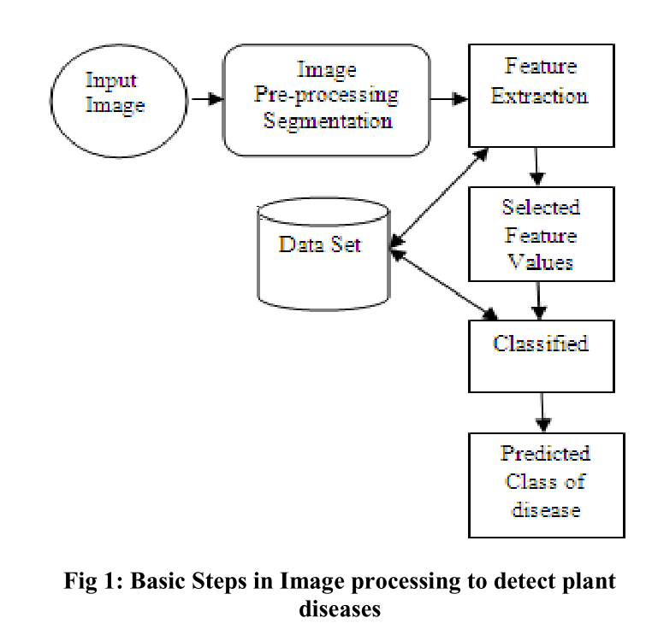

# Fig. 1. Basic steps in image processing to detect plant diseases

Feature extractions, is the process done after segmentation. According to the segmented information and predefined dataset some features of the image should be extracted. This extraction could be the any of statistical, structural, fractal or signal processing. Color co-occurrence Method, Grey Level Co-occurrence Matrices (GLCM), Spatial Gray-level Dependence Matrices (SGDM) method, Gabor Filters, Wavelets Transform and Principal component analysis are some methods used for feature extraction. Classifiers are the software routine written on the platform to define certain features for classification of the images. K- nearest neighbor, Radial basis function, Probabilistic Neural Network (PNN), Convolutional neural network, Support vector machine and Back propagation network are the some linear and non linear classifier for image classification. Any platform such as MATLAB can be used to train and test these classifiers. Further we are going to discuss different classifiers and also how multithreading can work with them. Multithreading can also be used in image processing if we are processing different features in an image instead of sequential processing we can use multithreading and save the resources and time as much as possible.

## K-nearest neighbor:

K-nearest neighbor is a simple classifier which determines the class of query by determining the distances from the centroids of all classes. The centroid with nearest to query is then declared the class of the query. Plant disease automatic detection is an important research topic as it has been proved useful in monitoring large crop fields, and thus automatically detects the leaf disease symptoms as soon as they appear in plant leaves. In this paper, a plant disease recognition method is proposed based on plant leaf images. First, the spot is segmented, and the disease feature vector is extracted. Then, the extracted features are provided for the K-nearest-neighbor classifier to recognize the plant diseases. Experimental results show the effectiveness of the proposed approach.

# Fig. 2. Comparison of knn algorithm when a new point falls

The most critical part of this algorithm is to choose features carefully, as the accuracy depends on it. The K-Nearest Neighbor (KNN) Classifier is works well on basic recognition problems. In the initial step, the RGB images of all the leaf samples are picked up. The step-by-step procedure of the proposed system: (1) Acquisition and preprocessing the disease leaf RGB image; (2) Transforming the input disease leaf image from RGB to HSV format space; (3) Masking the green-pixels and remove the stem and the masked green pixels; (4) Segmenting the spot components, obtain the useful spot; (5) Extracting the recognition features of color, shape and texture; (6) Configuring the K nearest neighbor classifier for the disease recognition. The disadvantage of this algorithm is that it is a slow learner, it does not learn anything from training data rather learns and acts from scratch each time it runs on the data. Secondly, it calculates distances from each centroid then sort all the training data accordingly then again this cycle run until query’s class is detected, this procedure is slow and takes time( Arora, 2014).

## 3. K-nearest Neighbor using MPI and POSIX Threads

Instead of computing the new clusters in each iteration in a single process, The MPI program first loads the clusters from the datasets in Process 0 and the assign each computation of distance evaluation a POSIX thread, this means that with every step nearer to the classification, one cluster is simply using a thread and all the clusters are utilizing the multiprocessor capability. This results enhancement of speed and no conflict in synchronization or read/write occurs. Experiments also prove that the consideration of the hyper-threading capabilities of current processors provide an additional gain factor in the speed-up, being able to run more threads than physical processors are available(Aparício et al., 2007). A comparison of the MPI and sequential KNN is given by (Aparício et al., 2007)

**Fig. 3.** A comparison of the speed of Sequential and MPI KNN techniques(View the second and third peeks)(Aparício et al., 2007)

## 4. Support Vector Machine:

Support Vector Machine is a non-linear Classifier where the data is mapped non-linearly over a high dimensional space. There are two classes under consideration and the distance between them is called the hyper plane i.e., divider. This hyper plane maximizes the margin between two classes. The sample closest to the margin are called the Support Vectors and considered the part of the class. SVM can also be applied to multi-class, in which the SVM between two classes is applied as one-to-all or one-to-one style(Computing, 2015).

**Fig. 4.** Comparison of two class svm

The primary advantages of SVM are that its accuracy is high, it is robust, its geometric interpretation is very simple, and the computational complexity does not depend upon the dimensionality of input space. The main disadvantages of SVM includes that it takes time to train, large number of support vectors are used for performing the classification task and it is difficult to understand.

## 5. Multi-Threading in SVM

Resources are optimized using multi-threading techniques in SVM. In case of single threaded process and large datasets, SVM results in drop of accuracy and memory limitation in case of single CPU. However, in case of Raspberry Pi, when multiple threads are used for SVM model detection it results in high accuracy and the tracking performance is improved for real-time(Fook et al., 2020).

The pseudo code for multi-threaded SVM is given as

A comparison of Single-Threaded SVM and Multi-Threaded SVM Performance using Raspberry Pi is given by the following table (Fook et al., 2020)

**Table 1.** Comparison of parameters with and without multi-threading

|  |  |  |  |
| --- | --- | --- | --- |
| **Parameters Threads Used** | **Without Multi-Threading**  **1** | **With Multi-Threading**  **2 4** | |
| FPS | 10 | 15 | 30 |
| CPU Usage | 9.4% | 7.5% | 7.6% |
| Memory | 85.4% | 86.2% | 80.3% |

## 6. Neural Networks

The diseased plants are generally differentiated from healthy plants by the leaves. The crops are monitored continuously and the leaves are observed, if a patch of leaf is different (belongs to a specific type of sickness/disease) the it is qualified for a class of a specific type of disease (A. & L. N., 2017).

A digital image of the subject is passed through the model, this model then creates a grid of the image where it declares the colored region of grid as diseased part of the plant while the colorless region is known as the healthy part of the plant. Artificial neural network ANN is used which has 10 inputs and 2 outputs declaring healthy and diseased parts of the image, while the inputs from 1-10 are the color ranges varying from the color of a healthy plant to a diseased plant. The accuracy of the result increases when input range increases (Abdullakasim et al., 2011)

**Fig. 5.** ANN Architecture for the classification of healthy and diseased plants

Mean Value is calculated for each pixel value and used as a representative for each block of (80 x 80). By varying the number of sample (5270) and the input color range, ANN applied to the data and the results viewed in (Abdullakasim et al., 2011) are as following

**Table 2.** Comparison between ranges of healthy plants and diseased plants

|  |  |  |
| --- | --- | --- |
| **Indices** | **Ranges of index Values** | |
|  | **Healthy Plants** | **Diseased Plants** |
| R | 0.1044-0.7790 | 0.1325-0.9184 |
| G | 0.1419-0.9359 | 0.1808-0.9771 |
| B | 0.0617-0.7358 | 0.0261-0.6790 |
| r-g | -0.03036-0.0539 | -0.2793-0.0842 |
| g-b | 0.0282-0.4880 | 0.0409-0.5425 |
| (g-b) / | r-g | | 0.5179-10.5600 | 0.5315-26.7671 |
| 2g-r-b | 0.0187-0.7548 | 0.0548-0.7469 |
| H | 0.1049-0.4382 | 0.1117-0.3993 |
| S | 0.0673-0.8432 | 0.1081-0.9439 |
| I | 0.1168-0.7882 | 0.1168-0.8370 |

**Fig. 6.** This histogram shows the ratio of diseased and Healthy plants.

Here the index ratio is the primary factor differentiating between healthy and diseased plant. The accuracy of this algorithm is 79.23%.

## 7. Multi-Threaded Learning Control Mechanism for neural Networks

The algorithm described earlier can be implemented using multi-Threaded learning technique. The basic idea is that train some neural networks for competing in current session, then select the best trained neural network in each thread and then again choose the best competing neural network among all these selected neural networks (Połap et al., 2018)

For a classification problem, in our case, it is classification of the plant diseases, detect the number of cores in the computer, for each core, Create a neural Classifier with constant number of small iterations. Train the neural network and then perform the following steps:

* Calculate the smallest average drop value θ1.
* Replace neural networks with new Classifier weights.
* Train the neural network and achieve the specific error.
* Replace the worst value with the new one.
* Repeat until the best neural network is achieved.

The results are merge in a mechanism of training the neural networks in parallel fashion where benefits of multi-core processing are achieved.(Połap et al., 2018) has described several dataset error1 and error2 comparisons.

## 8. Segmentation and Feature Extraction Technique

The main idea is that, convert the RGB image into HSV format, mask the green components, remove them, obtain useful segments and the process the selected segments(Sanjay B. Dhaygude, 2013).

Now, to impose Multi-Threading, K-mean clustering algorithm or multi-threaded segmentation is can be implemented. Where the results as exposed earlier are much more reliable. Multi-core services are availed. By using K-mean clustering algorithm with multi-threading efficiency is achieved.(Bose et al., 2013). Following are the results when number of clusters are 2 Fig A,4 Fig B,6 Fig C

**Fig. 7(A).** Number of clusters are 2

**Fig. 7(B).** Number of clusters are 4

**Fig. 7(C).** Number of clusters are 6

Here, in Fig A, number of clusters are 2. You can clearly see that the Multi-Threaded classifier is much more efficient, and the efficiency increases as the number of threads increase. In next two Fig B and Fig C, the number of clusters (classes) are increase by 2. The behavior in case of single thread and Multi-threaded models remains as described by (Bose et al., 2013).

## 9. Statistical Analysis with Advanced Image Processing

Plant diseases like canker, late blight effects on stems and leaves are detected and classified by using the above techniques and algorithms. Now comes the statistical part. By applying the program on samples, Draw the histograms of the samples. Then match those histograms with the Histogram of the diseased plant, histogram of healthy plants. The percentage of matching highlights the percentile of plant that is affected with the disease.

**Fig. 8.** Percentile of plants that is affected with the disease

Finally, the program declares the sample as one of the following conclusions i.e., Diseased or Not Diseased (S et al., 2017). This similar fashion can be applied for specific type of disease.

## 10. Plant Disease Severity Estimation using Deep Learning

Diseases like apple black rot are detected using Image-based approach by using Deep Convolutional neural Networks. The base is the same means creating a neural network from scratch , training it and the selecting the best one. But here is the thing which differs, that is ReLU is used. The shallow networks consist of only few convolutional layers with few filters per layer, followed by two fully connected layers, and end with a SoftMax normalization. We train shallow networks of 2,4,6,8, and 10 convolutional layers. Each convolutional layer has 32 filters of size 3 × 3, a Rectified Linear Units (ReLU) activation, and all layers are followed by a2 × 2 max-pooling layer, except for the last convolutional layer, which has 64 filters. The first fully connected layer has 64 units with a ReLU activation and is followed by a dropout layer with a dropout ratio of 50%. The last fully connected layer has 4 outputs, corresponding with the 4 classes, which feed into the SoftMax layer to calculate the probability output.(Wang et al., 2017)

|  |  |  |
| --- | --- | --- |
| **Class** | **Number of Images for training** | **Number of Images for Testing** |
| Healthy Stage | 110x 12 | 27x12 |
| Early Stage | 108 | 29 |
| Middle Stage | 144 | 36 |
| End Stage | 102 | 23 |
|  |  |  |

Fully connected layers are added on top of the final convolutional layer. The loss function measures the discrepancy between the predicted result and the label of the input, which is defined as the sum of cross entropy

**Table 3.** Number of Samples of training and Testing Images

**Fig. 8.** Graph of accuracies of Shallow networks

This deep learning approach automatically discovers the discriminative features for fine-grained classification, which enables the end-to-end pipeline for diagnosing plant disease severity.

**Table 4.** Accuracy of deep learning neural Network for apple black rot

|  |  |
| --- | --- |
| Classes | Accuracy |
| Healthy Stage | Close to 100% |
| Early Stage | 93.1% |
| Middle Stage | 83.3% |
| End Stage | 87.0% |

## 11. Color Transform Based Approach

An algorithm for disease spot segmentation using image processing techniques in plant leaf is implemented. This is the first and important phase for automatic detection and classification of plant diseases. Disease spots are different in color but not in intensity, in comparison with plant leaf color. So, we color transform of RGB image can be used for better segmentation of disease spots. In this paper a comparison of the effect of CIELAB, HSI and YCbCr color space in the process of disease spot detection is done. Median filter is used for image smoothing. Finally, threshold can be calculated by applying Otsu method on color component to detect the disease spot. An algorithm which is independent of background noise, plant type and disease spot color was developed and experiments were carried out on different “Monocot” and “Dicot” family plant leaves with both, noise free (white) and noisy background. (Kumar, R. (2012))

Nunik Noviana Kurniawati et al (Nunik Noviana Kurniawati, Siti Norul Huda Sheikh Abdullah, Salwani Abdullah, Saad Abdullah, “Investigation on Image Processing Techniques for Diagnosing Paddy Diseases”) introduced a method for detection and classification of paddy disease. In this method Otsu threshold is used for disease spot detection and unnecessary spots are removed using median filter. Geng Ying et al (Geng Ying, Li Miao, Yuan Yuan and Hu Zelin, “A Study on the Method of Image Pre-Processing for Recognition of Crop Diseases”) studied the method of image pre-processing for detecting the disease spot. In this paper median filter is used for image smoothing. Threshold technique is used to convert filtered image into binary image and finally using edge detection technique, disease spot is detected. Using above techniques disease spot can be detected in “Monocot family” plants, in which mostly veins are parallel and less visible (http://theseedsite.co.uk/monocots2.html), (http://www.backyardnature.net/mondiclf.htm). Problem occurs when the same technique is applied on “Dicot family” plants to detect the disease spot, in which veins form a netted pattern. In dicot plant leaves, larger veins are thicker and straighter.

(http://theseedsite.co.uk/monocots2.html),(http://www.backyardnature.net/mondiclf.htm). In the process of disease spot detection disturbance mainly occurs because of these thicker veins.

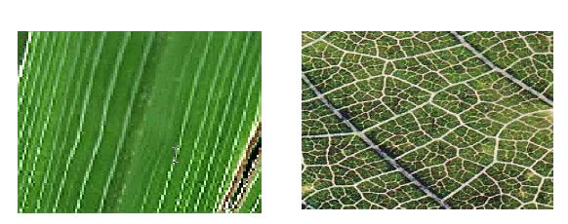

**Fig. 9.** Comparison of veins in diseased and healthy plant leaf

Left picture contains monocot family of plants and right picture contains dicot family plant leaf.

All the images in collection are in JPEG format. These images are color transformed from RGB image to one of the color space named by YCbCr, HIS and CIELAB color spaces. The color transformed images are passed through median filter to remove unnecessary spots. In last step Otsu threshold is applied on RGB image, ‘A’ component of CIELAB color space, ‘H’ component of HSI color space and ‘Cr’ component of YCbCr color space is used to detect the disease spot. The disease spot segmented images, obtained by all the three methods are compared to get the best method for disease spot detection.

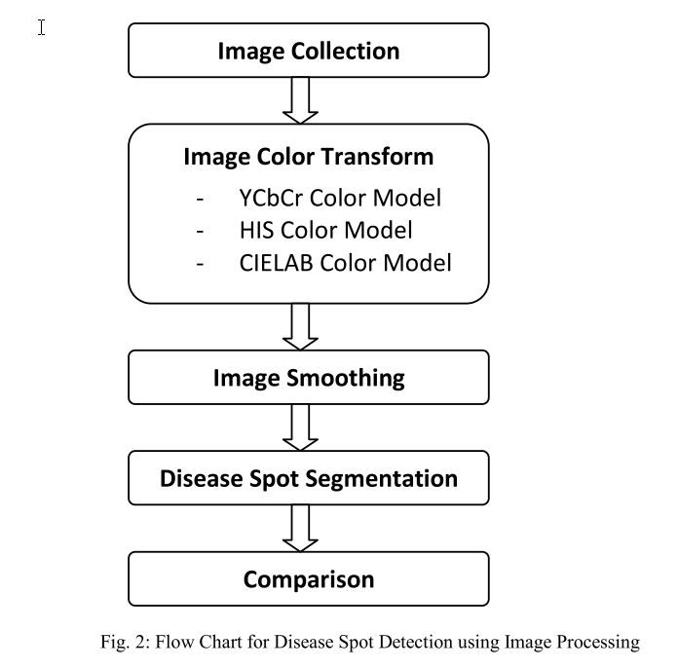

**Fig. 10.** Flowchart for disease for detection using image processing

In this research, images of rice, corn, wheat, iris, cotton, soybean, mustard, magnolia, apple and cherry leaf are collected to find the best method for disease spot detection, which is not affected by background and type of plant leaf. Four methods are discussed here.

* Method 1: disease spots are segmented by applying Otsu threshold on RGB image.
* Method 2: in second method RGB image is first converted into YCbCr color space using color transform formula. Then median filter is used for image smoothing. Disease spots are detected by applying Otsu threshold on ‘Cr’ component of filtered YCbCr color space.
* Method 3: this is similar to method 2. Only difference is that in place of YCbCr color space RGB image is transformed into HSI color space and disease spots are detected by applying Otsu threshold on ‘H’ component of filtered HSI color space.
* Method 4: again, same process is repeated using CIELAB color space. Disease spots are segmented by applying Otsu threshold on ‘A’ component of filtered LAB color space. Experimental results for disease spot detection of iris leaf affected by heterosporium leaf spot disease using different methods.

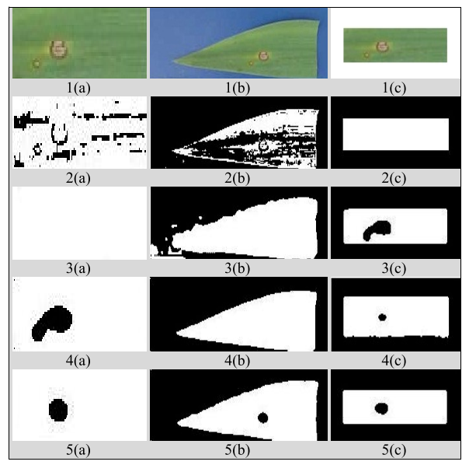

**Fig. 11.** RGB image of iris leaf affected by heterosporium leaf spot disease, without background(1(a)), with noisy background(1(b)), with noise free background(1(c)) and their respective results of disease spot detection using Method 1(2(a,b,c)), Method 2 (3(a,b,c)), Method 3 (4(a,b,c)) and Method 4 (5(a,b,c)

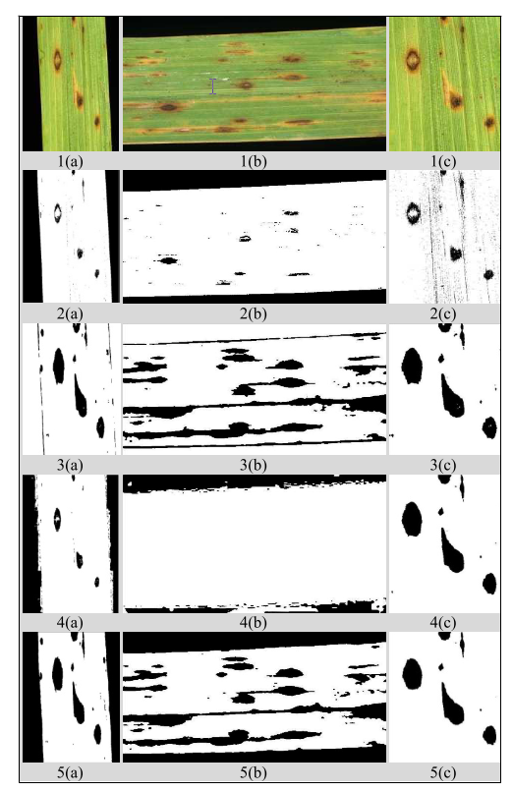

**Fig. 12.** RGB image of iris leaf affected by heterosporium leaf spot disease, without background(1(a)), with noisy background(1(b)), with noise free background(1(c)) and their respective results of disease spot detection using Method 1(2(a,b,c)), Method 2 (3(a,b,c)), Method 3 (4(a,b,c)) and Method 4 (5(a,b,c)



**Fig. 13.** RGB image of brown spot disease on rice leaf, with noisy background(1(a,b)), without background(1(c) and their respective results of disease spot detection using Method 1(2(a,b,c)), Method 2 (3(a,b,c)), Method 3 (4(a,b,c)) and Method 4 (5(a,b,c)

# Results

Results shows by using deep learning or neural networks plant disease detection can be improved the more we train a data set we can get more accurate results. Deep learning techniques can be improved using multithreading algorithms as discussed in literature review hence we can improve the efficiency of system by means of resources and results by using multithreaded algorithms.

**Table 5.** Comparison between training and test res

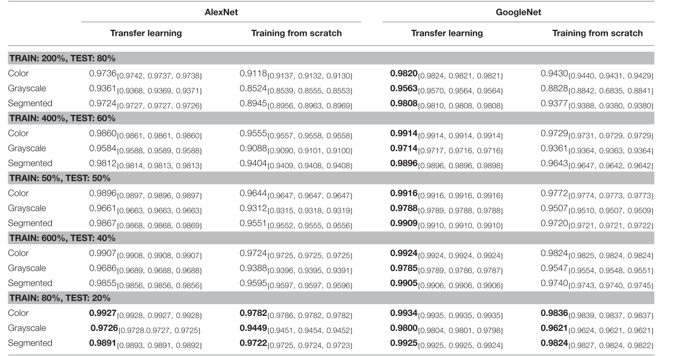

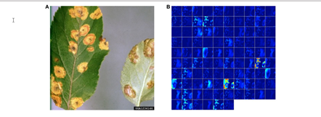

**Fig. 14.** Visualization of activation in the initial layers of an AlexNet Architecture and LeNet architecture.

# Acknowledgements

This work was supported in part by the Dr. Aslam professor at University and Engineering and Technology Lahore. The authors also gratefully acknowledge the support of fellow peers and professors who guided along

# References:

A., I., & L. N., O. (2017). Digital Image Processing for Detecting and Classifying Plant Diseases. *Circulation in Computer Science*, *2*(11), 1–7. https://doi.org/10.22632/ccs-2017-252-66

Abdullakasim, W., Powbunthorn, K., & Unartngam, J. (2011). An Images Analysis Technique for Recognition of Brown Leaf Spot Disease in Cassava. *Tarım Makinaları Bilimi Dergisi*, *7*(2), 165–169.

Aparício, G., Blanquer, I., & Hernández, V. (2007). A parallel implementation of the K nearest neighbours classifier in three levels: Threads, MPI processes and the grid. *Lecture Notes in Computer Science (Including Subseries Lecture Notes in Artificial Intelligence and Lecture Notes in Bioinformatics)*, *4395 LNCS*, 225–235. https://doi.org/10.1007/978-3-540-71351-7_18

Arivazhagan, S., Shebiah, R. N., Ananthi, S., & Vishnu Varthini, S. (2013). Detection of unhealthy region of plant leaves and classification of plant leaf diseases using texture features. *Agricultural Engineering International: CIGR Journal*, *15*(1), 211–217.

Başa, B. (2015). Implementation of Hog Edge Detection Algorithm Onfpga’s. *Procedia - Social and Behavioral Sciences*, *174*, 1567–1575. https://doi.org/10.1016/j.sbspro.2015.01.806

Bose, S., Mukherjee, A., Madhulika, Chakraborty, S., Samanta, S., & Dey, N. (2013). Parallel image segmentation using multi-threading and k-means algorithm. *2013 IEEE International Conference on Computational Intelligence and Computing Research, IEEE ICCIC 2013*, *December 2012*. https://doi.org/10.1109/ICCIC.2013.6724171

Computing, M. (2015). *A Review on Off-line Leaf Recognition Using Neural Network*. *4*(1), 478–482.

Fook, W. S., Rahman, A. H. A., Sani, N. S., & Adam, A. (2020). Resource optimisation using multithreading in support vector machine. *International Journal of Advanced Computer Science and Applications*, *11*(4), 356–359. https://doi.org/10.14569/IJACSA.2020.0110449

Geng Ying, Li Miao, Yuan Yuan and Hu Zelin, “A Study on the Method of Image Pre-Processing for Recognition of Crop Diseases”, International Conference on Advanced Computer Control, 2008 IEEE, pp. 202-206.

Ghaiwat, S. N., & Arora, P. (2014). Detection and Classification of Plant Leaf Diseases Using Image processing Techniques: A Review. *International Journal of Recent Advances in Engineering & Technology (IJRAET) ISSN (Online*, *2*, 2347–2812.

Gilmour, P. S. (1991). How to select tools for rnicrocontroller software. *IEEE Spectrum*, *28*(2), 37–39. https://doi.org/10.1109/6.100908

Gui, J., Hao, L., Zhang, Q., & Bao, X. (2015). A new method for soybean leaf disease detection based on modified salient regions. *International Journal of Multimedia and Ubiquitous Engineering*, *10*(6), 45–52. https://doi.org/10.14257/ijmue.2015.10.6.06

http://theseedsite.co.uk/monocots2.html, Accessed on april 28, 2012

http://www.backyardnature.net/mondiclf.htm, Accessed on april 28, 2012

Kika, A., & Greca, S. (2013). Multithreading Image Processing in Single-core and Multi-core CPU using Java. *International Journal of Advanced Computer Science and Applications*, *4*(9). https://doi.org/10.14569/ijacsa.2013.040926

Kim, D. G., Burks, T. F., Qin, J., & Bulanon, D. M. (2009). Classification of grapefruit peel diseases using color texture feature analysis. *International Journal of Agricultural and Biological Engineering*, *2*(3), 41–50. https://doi.org/10.3965/j.issn.1934-6344.2009.03.041-050

Kumar, R. (2012). FEATURE EXTRACTION OF DISEASED LEAF IMAGES Journal of Signal and Image Processing. *International Journal of Computer Science and Telecommunications*, *3*(1), 65–71. http://www.bioinfo.in/contents.php?id=48

Mohanty, S. P., Hughes, D. P., & Salathé, M. (2016). Using deep learning for image-based plant disease detection. *Frontiers in Plant Science*, *7*(September), 1–10. https://doi.org/10.3389/fpls.2016.01419

Nunik Noviana Kurniawati, Siti Norul Huda Sheikh Abdullah, Salwani Abdullah, Saad Abdullah, “Investigation on Image Processing Techniques for Diagnosing Paddy Diseases”, International Conference of Soft Computing and Pattern Recognition, 2009 IEEE, pp. 272-277.

Połap, D., Woźniak, M., Wei, W., & Damaševičius, R. (2018). Multi-threaded learning control mechanism for neural networks. *Future Generation Computer Systems*, *87*(May), 16–34. https://doi.org/10.1016/j.future.2018.04.050

S, D. B., P, S., P, S., S, S., & K, V. K. (2017). Advances in Image Processing for Detection of Plant Disease. *The SIJ Transactions on Computer Science Engineering & Its Applications (CSEA)*, *05*(02), 08–10. https://doi.org/10.9756/sijcsea/v5i2/05010140101

Sanjay B. Dhaygude, N. P. K. (2013). *Agricultural plant Leaf Disease Detection Using Image Processing*. *2*(1), 599–602.

Singh, V., & Misra, A. K. (2017). Detection of plant leaf diseases using image segmentation and soft computing techniques. *Information Processing in Agriculture*, *4*(1), 41–49. https://doi.org/10.1016/j.inpa.2016.10.005

Wang, G., Sun, Y., & Wang, J. (2017). Automatic Image-Based Plant Disease Severity Estimation Using Deep Learning. *Computational Intelligence and Neuroscience*, *2017*. https://doi.org/10.1155/2017/2917536